# Exercises: Web Fundamentals Introduction

Problems for exercises and homework for the [“Java Web Development Basics” course @ SoftUni](https://softuni.bg/courses/java-web-development-basics). Submit your solutions on the **course pag**e of the **current instance**.

In this homework you are supposed to **write java programs** that are run by a web server. You will learn how to create **HTML** content and how to use basic **HTTP** **GET** and **POST** methods. Moreover, you will have to store data in different data structures and write simple algorithms.

**Before you begin make sure you are have followed the tutorial “” on how to configure Apache Web Server.**

## By The Cake: First web site

Create a web site called **ByTheCake**. Write a java program that prints h1 header “By The Cake” and h2 header “Enjoy our awesome cakes”. Put a horizontal line afterwards. Invoke a CGI script that calls your java program.

### Example

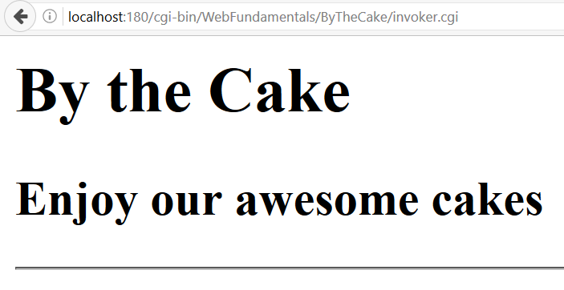

### Hint

Don’t forget to invoke your bash.

Windows:

*#! C:\cygwin64\bin\bash.exe*

*Linux:*

*#! /bin/sh*

*Then invoke your {program}.class*

*java -cp ./ CakeWebSite*

## By The Cake: Add menu

Extend your web site. Leave a blank row after the horizontal line. Add a menu as an **unordered list**. It should have four menu items. The Home item should have an ordered list with two list items. See the example below.

### Example

* Home
  + Our cakes
  + Our stores
* Add cake
* Browse cakes
* About us

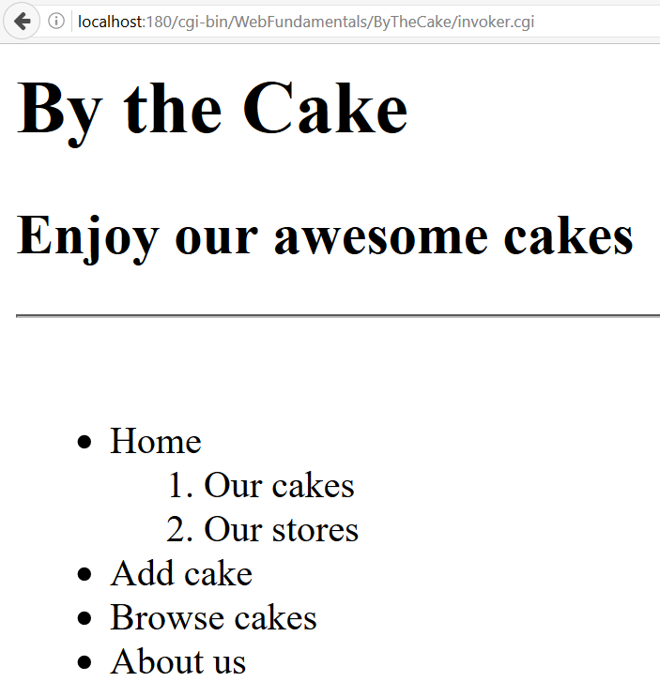

## By The Cake: Add paragraph

Extend your web site. Add h2 header called “Home”. It should have two sections. Each section has a h3 header, a paragraph and an image.

Section one should be with header “Our cakes”, paragraph with text “Cake is a form of sweet dessert that is typically baked. In its oldest forms, cakes were modifications of breads, but cakes now cover a wide range of preparations that can be simple or elaborate, and that share features with other desserts such as pastries, meringues, custards, and pies” and a random cake image.

Section two should be with header “Our stores”, paragraph with text “Our stores are located in 21 cities all over the world. Come and see what we have for you.” and a random cake store image.

### Example

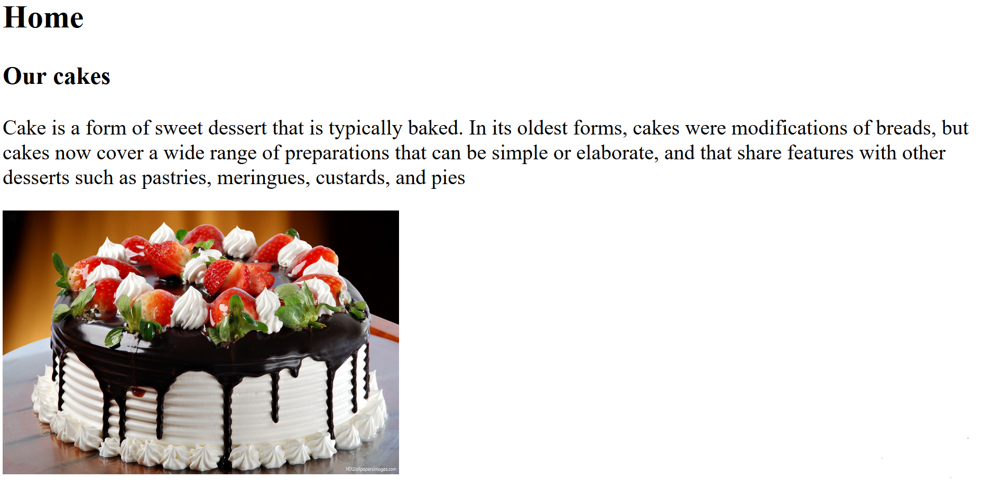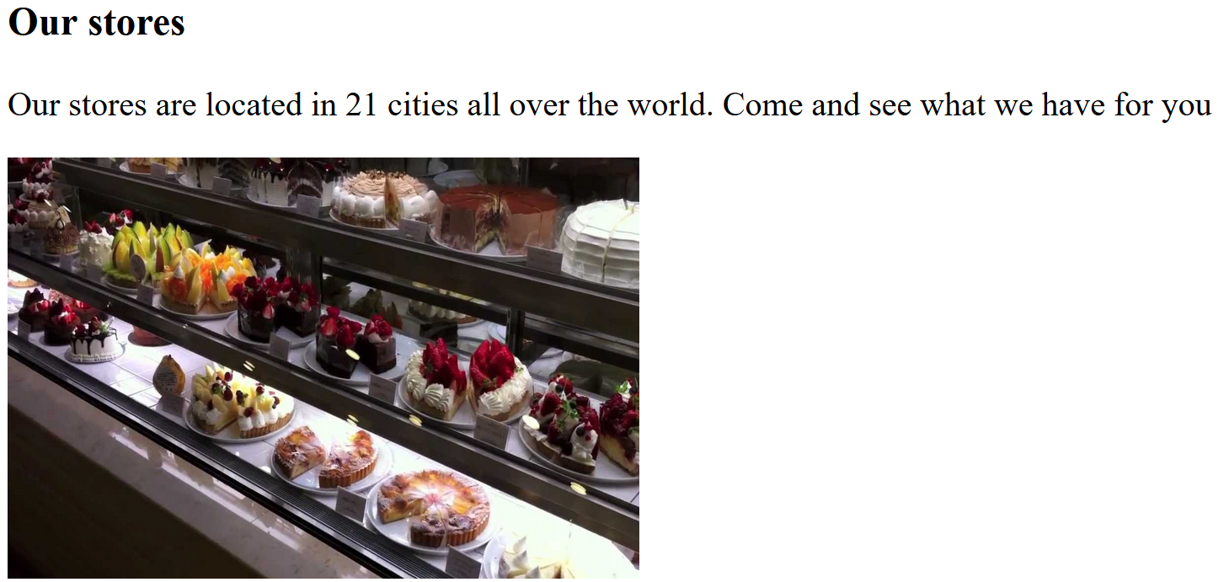

## By The Cake: Add links

Extend your web site. Add links for the menu we have. The Home item should reference **your current CGI script**. The Add cake should reference to **add_cake.cgi**. Browse cakes should reference to **browse_cakes.cgi**.

### Examples

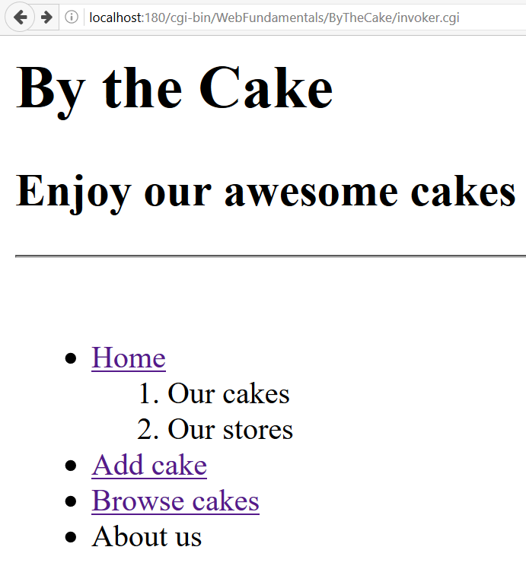

## By The Cake: Add fragments

Extend your web site. Add a fragment to **h3** **Our cakes** with name “**cakes**”. Add another fragment to **h3** **Our stores** with name “**stores**”. The menu item “**Our cakes**” should reference “**cakes**”. The menu item “**Our stores**” should reference “**stores**”.

### Examples

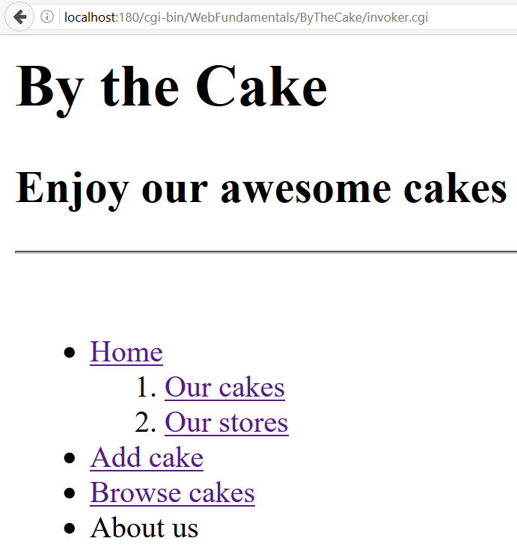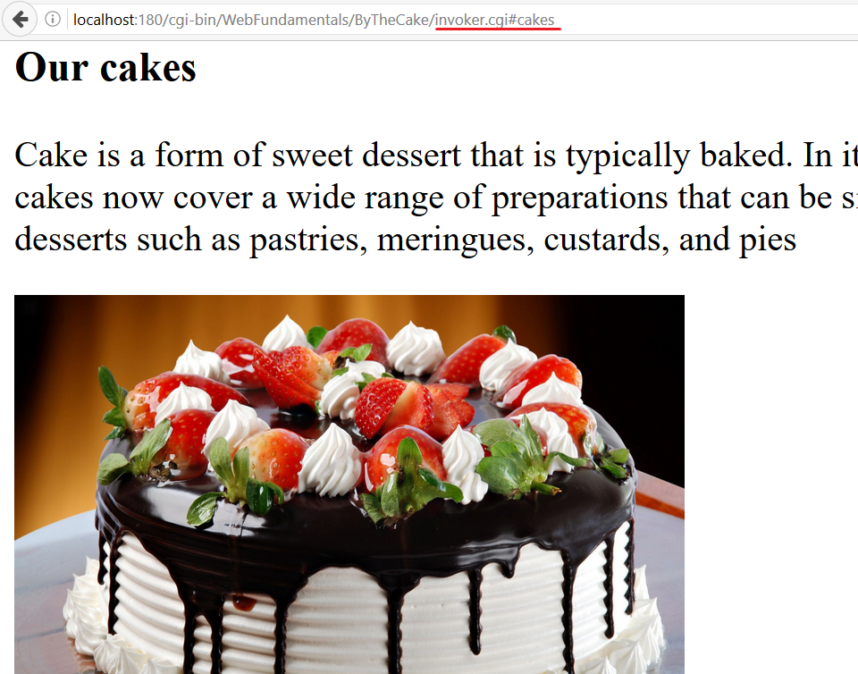

## By The Cake: Add footer

Extend your web site. Add footer which says ©All Rights Reserved. There should be a horizontal line above the footer. Center the text.

### Examples

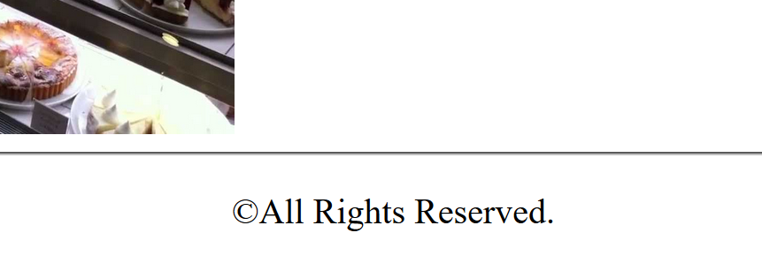

### Hint

Use *<footer></footer>* tag

To center the text of your paragraph use CSS. Consider the *text-align* property.

## By The Cake: Add head

Extend your web site. Now it is time to add some meta data. We need to set the following properties:

* Title: “By The Cake”
* Charset: UTF8
* Description: “Buy the cake in By The Cake”
* Keywords: “Cakes, Buy”
* Author: Your name

The meta data will help search engines to recognize your web site as a best match.

### Examples

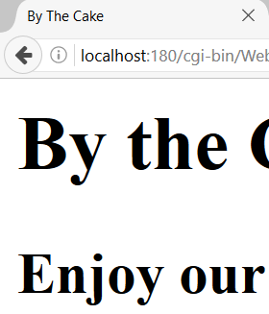

### Hint

Use *<head></head>* tag

## By The Cake: Add stores info

Extend your web site. Add preformatted text above the footer and below the last picture. Change the background color to #f94f80. The text should contain information about the stores as follows:

|  |  |
| --- | --- |
| City: HongKong Address: ChoCoLad 18 Phone: +78952804429 | City: Salzburg Address: SchokoLeiden 73 Phone: +49241432990 |

### Examples

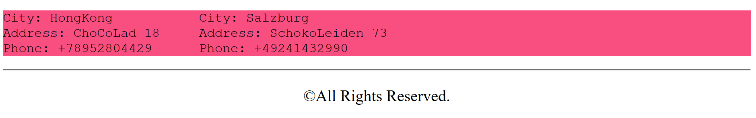

### Hint

Use *<pre></pre>* tag

Use CSS only to change the background color

## By The Cake: Add about info

Extend your web site. Create **a h2 header** with text “About us” followed by a definition list. Put the information just above the store info. The definition list should have two texts with a single definition each.

* ByTheCake EOOD
  + Name of the company
* {Your Name}
  + Owner

Create a **fragment** that will lead to “About us” just like in Exercise 5.

### Examples

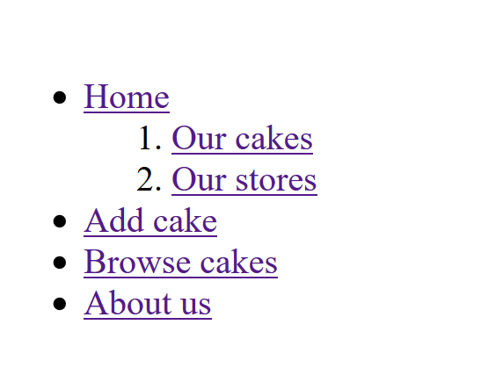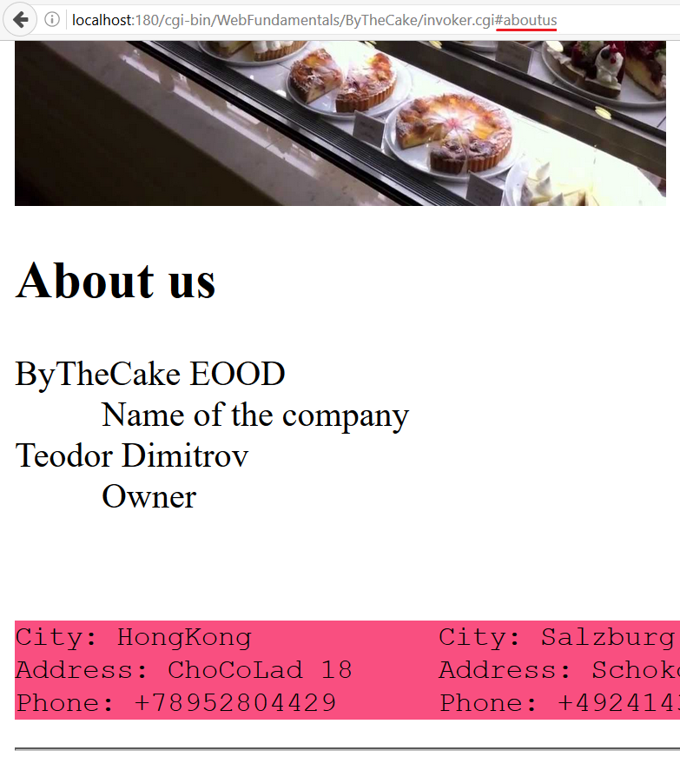

## By The Cake: Emphasize the words

Extend your web site. Find the words “sweet desert, cake, store” and make them **bold** and *italic*.

### Examples

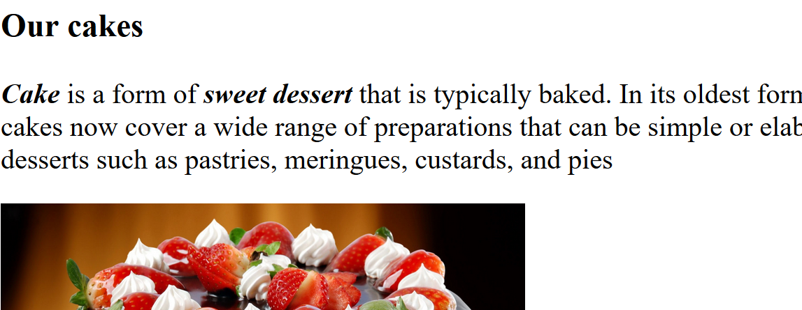

## ** By The Cake: add_cake.cgi

Extend your web site. Create a CGI script called **add_cake.cgi**. Write another program which will be responsible for adding cakes functionality. It should have a simple form to add cakes. **Create a Cake class**. Each cake should have name and price. When you click the submit button a new cake should be created and saved in a list. The newly created cake should be printed below the form. **“name”** and **“price”** are the parameters of the request.

**In order to work create a functionality which processes POST requests.**

### Examples

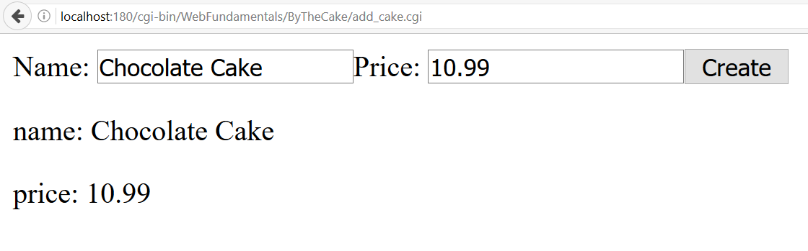

### Hint

Don’t forget to add CGI parameters during invocation of your java program.

-Dcgi.query_string=$QUERY_STRING

-Dcgi.request_method=$REQUEST_METHOD

## By The Cake: Write data

Extend your web site. The submitted data should be appended on a new row split by comma in a file called **database.csv**. Add a link to go back to your main page.

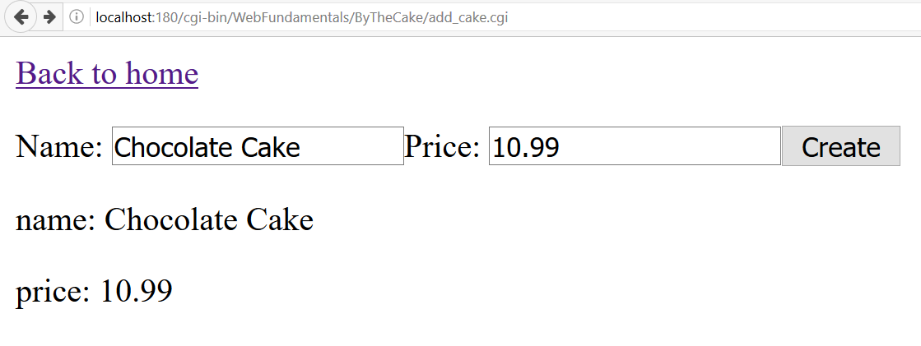

## ** By The Cake: browse_cakes.cgi

Extend your web site. Crate a new program that should print a single form **with GET method**. See the example below. It will be used to search cakes by name. Cakes should be searched from **database.csv** and printed below the form.

Add a functionality to go back to your main page.

You will need a third CGI script called **browse_cakes.cgi** to invoke your program.

### Examples

**database.csv***Chocolate cake,10.99  
Banana cake,8.59*

